
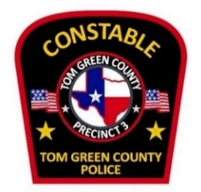
3052 N. Bryant Blvd. San Angelo, TX 76903 Office: 325-653-5232

TOM GREEN COUNTY CONSTABLE’S OFFICE PRECINCT 3

OPEN POSITION
Job title: Reserve Deputy Constable
Department: Precinct 3 Constable’s Office
Open date: 1/22/2026 Close: open until filled
Job summary
Under the general supervision of the Constable or Senior Deputy in charge, the reserve deputy may be asked to perform a variety of law enforcement duties to include any of the following below.
. Service of any civil or criminal process issued to our department in a timely manner.
. Executing writs issued to our department.
. Executing arrest warrants issued to our department.
. Investigating public nuisance complaints filed by citizens of Tom Green County.
. Providing Court Security for the JP court as needed.
. Assisting other agencies as needed.
. Enforcement of State laws through arrest and or citations to appear.
. Must be willing to work a minimum of 16 hours per month to stay commissioned.
Minium job requirements
Certified Peace Officer through the Texas Commission on Law Enforcement (TCOLE) with current up to date license. Must pass a background check with no convictions above a class c misdemeanor. Must have a valid Texas driver’s license in good standing with a satisfactory driving record and not be prohibited from carrying/possessing a firearm. Must have a valid high school diploma or GED and be 21 years of age or older.
Preferred qualifications
Intermediate Peace Officer, or above with a minimum of 5 years’ experience, is preferred but not necessarily required. Interested candidates may contact the Constable’s Office for a background packet.

