Eyewitness
Evidence/Identification

Course # 3286
July 2022
Eyewitness Evidence/Identification
ABSTRACT
Eyewitness evidence is critical to the apprehension and prosecution of criminals. Since 1989, DNA evidence has been used to exonerate nearly 200 individuals that were wrongfully convicted and imprisoned. Of those, approximately 75% were convicted on evidence that included inaccurate and faulty eyewitness identifications. Research has proven that a number of small changes to the identification process will help improve the accuracy and reliability of eyewitness identification, ensuring that the highest quality of eyewitness evidence is collected and preserved.
This course is designed to provide individuals with a knowledge and understanding of how the implementation of recommended protocols, or best practices, can improve the accuracy and reliability of eyewitness evidence.
Note to Trainers: It is the responsibility of the training coordinator to ensure this curriculum and its materials are kept up to date. Refer to curriculum and legal resources for changes in subject matter or laws relating to this topic as well as the Texas Commission on Law Enforcement website at www.tcole.texas.gov for edits due to course review.
Target Population: Licensed law enforcement peace officers in Texas
Student Prerequisites:
- None
Instructor Prerequisites:
- Certified TCOLE Instructor with prior eyewitness evidence/identification course completion OR
- Documented subject matter expert
Note: It is highly recommended that subject matter experts are obtained as guest speakers for a quality learning experience. These experts could include: representatives from advocacy organizations with expertise in eyewitness evidence, law enforcement administrators responsible for establishing policy for their agency, prosecuting attorneys, and/or legal scholars with background in eyewitness evidence procedures.
Length of Course: 8 hours minimum
Required Equipment:
- None
Training Delivery Method(s):
- Online
- Instructor-led, classroom-based
- Instructor-led, virtual
Method(s) of Instruction:
- Lecture
- Discussion
- Scenarios
- Videos
Facility Requirements:
- Standard classroom
Assessment: Assessment is required for completion of this course to ensure the student has a thorough comprehension of all learning objectives. Training providers are responsible for assessing and documenting student mastery of all objectives in this course.
In addition, the Commission highly recommends a variety of testing/assessment opportunities throughout the course which could include: oral or written testing, interaction with instructor and students, case study and scenario, and other means of testing student’s application of the skills, as the instructor or department deems appropriate.
Unless otherwise indicated, the minimum passing score shall be 70%.
Reference & Resource Materials:
- LEMIT Publication: Model Policy on Eyewitness Identification
- NIJ Publication: Eyewitness Evidence: A Guide for Law Enforcement
- NIJ Publication: Eyewitness Evidence: A Trainer’s Manual for Law Enforcement
- The Justice Project: Eyewitness Identification Procedures in Texas
- The National Registry of Exonerations: Exonerations by State: Texas
- CCP 38.20
- HB 34, 85th Regular Session
Eyewitness Evidence/Identification
Learning Objectives
- Reliable Eyewitness Evidence/Identification
  - Learning Objective: The student will be able to describe the need for improving the accuracy and reliability of eyewitness identification.
  - Learning Objective: The student will be able to list three stages of memory.
  - Learning Objective: The student will be able to explain two primary variables that cause eyewitness misidentification.
  - Learning Objective: The student will be able to list the general strategies for interviewing the witness.
- Field Identification Procedure
  - Learning Objective: The student will be able to describe the procedures for properly conducting the show-up.
  - Learning Objective: The student will be able to identify the elements required to properly record the show-up results.
- Mugbooks and Composites
  - Learning Objective: The student will be able to describe the procedures used to properly prepare a mugbook.
  - Learning Objective: The student will be able to describe the procedure in developing and using composite images.
  - Learning Objective: The student will be able to list the recommended instructions provided to the witness prior to viewing a mugbook.
  - Learning Objective: The student will be able to list the recommended instructions provided to the witness prior to viewing a composite Image.
  - Learning Objective: The student will be able to list the recommended procedures for documenting the identification procedure.
- Procedures for Eyewitness Identification of Suspects
  - Learning Objective: The student will be able to describe the recommended procedure for composing and conducting photographic lineups.
  - Learning Objective: The student will be able to describe the recommended procedure for composing and conducting live lineups.
  - Learning Objective: The student will be able to list the recommended procedures for instructing the witness prior to viewing the photo array and live lineup.
  - Learning Objective: The student will be able to describe recommended procedures for instructing the witness prior to viewing for different methods of lineup.
  - Learning Objective: The student will be able to describe the common procedure for composing and conducting the lineup identification procedure.
  - Learning Objective: The student will be able to identify the elements required to properly record the identification results for photo lineups and live lineups.
Eyewitness Evidence/Identification

UNIT 1. Reliable Eyewitness Evidence/Identification

The student will be able to describe the need for improving the accuracy and reliability of eyewitness identification.
- According to the Innocence Project executive summary, over 240 people, serving an average of 13 years in prison, have been exonerated through deoxyribonucleic acid (DNA) testing in the United States.
  - It is estimated that 63% of those wrongful convictions involved eyewitness misidentification.
  - In 38% of the misidentification cases, multiple eyewitnesses misidentified the same innocent person.
  - In 50% of the misidentification cases, eyewitness testimony was the central evidence used against the defendant without other corroborating evidence like confessions, forensic science or informant testimony.
  - In 36% of the misidentification cases, the real perpetrator was identified through DNA evidence.
- According to the Innocence Project, contributing causes of wrongful convictions:
  - 15% of informants
  - 27% of false confessions
  - 47% of unvalidated or improper forensic science
  - 72% of eyewitness misidentification
Note: Total is more than 100% because wrongful convictions can have more than one cause.
- As of 2022, the National Registry of Exonerations found that Texas led the nation with 400 exonerations in the last 30 years. Texas has had more wrongful convictions exposed by DNA than any other state in the country (70 at the time of posting). Collectively, these individuals have an average of 16.1 years lost.
Note: You can view the current dashboard for Texas and apply filters for different contributing factors by visiting: https://public.tableau.com/shared/R7NDG5MK9?:display_count=y&:origin=viz_share_link&:embed=y
- Since 2009, Texas law provides that persons wrongfully imprisoned are eligible to be paid a lump sum of up to $80,000 for each year they spent in prison. They also are eligible to receive monthly annuity payments for another $80,000 total per year as long as they live, provided they aren’t later convicted of a felony. In the last 25 years, Texas has paid over $93 million to wrongfully convicted individuals.
- To prevent wrongful convictions, Governor Greg Abbott has signed critical legislation House Bill 34 into law in 2017 to set up best practices for police departments conducting eyewitness identification in a professional way. This bill added to other Eyewitness Evidence requirements put in place in 2011. This legislation was considered landmark legislation protecting Suspects rights and preventing innocent people form going to prison. This new Texas law was viewed around the nation as “The Gold Standard” of eyewitness identification reform. This bill added to Texas Code of Criminal Procedure 38.20. Mandated agencies with Peace Officers who routinely administer photo lineups SHALL adopt the policy of the Bill Blackwood Law Enforcement Management Institute of Texas’ (LEMIT) model policy.
INSTRUCTOR NOTE:
- Show Appendix A: Texas Convictions, Wrongful Convictions Improper or Mistaken Witness Id, from website of The National Registry of Exonerations. This lists represent 36 people in the State of Texas whose wrongful convictions were because of improper or mistaken eyewitness identification. It also represents prison sentences ranging from probation to the death penalty for a conviction based on bad evidence. This means that these 36 people lost their freedom because of improper eyewitness identification, and equally important, it also means the victims did not receive justice in their cases.
- Play the video from CBS News “Eyewitness Testimony Part 1” if applicable https://www.youtube.com/watch?v=u-SBTRLoPuo (13:00) or discuss a real case based on the same topic.

The student will be able to list three stages of memory.
Many of these misidentifications could have been prevented and many wrongful convictions averted. Understanding how human memory works is a necessary step to prevent faulty eyewitness identifications and to better understand how humans remember things and what affects how those memories are recalled.
There are 3 stages of memory, and these stages are very similar to how computer memory is utilized.
- Encoding. When we are exposed to information of any kind, we take the information and begin processing it in visual, acoustic, and semantic form.
- Storage. This stage deals with nature of the memory where the information is stored, time duration of the memory, the amount of information that can be stored, and type of memory. The manner in which information is stored directly affects the way in which information is retrieved. Information is stored in two main parts of memory: Short-Term Memory (STM) and Long-Term Memory (LTM). STM total capacity ranges from 0–30 seconds while LTM can last a lifetime.
- Retrieval. This refers to getting information out storage. If we can’t remember something, it may be because we are unable to retrieve it. Organizing information can help aid retrieval:
  - STM is stored and retrieved sequentially.
  - LTM is stored and retrieved by association.
INSTRUCTOR NOTE: Dr. Jennifer Dysart explains how memory affects identification and how to prevent eyewitness misidentifications. YouTube video “Human factors of wrongful conviction: eyewitness identification”
https://www.youtube.com/watch?time_continue=127&v=dLNyzAE3k9g&feature=emb_logo (4:23)

The student will be able to explain two primary variables that cause eyewitness misidentification.
There are two primary variables that affect the witnesses’ ability to provide law enforcement with a solid identification.
- Estimator Variables (are beyond the control of the police)
  - Lighting and distance
  - Exposure and duration
  - Weapon focus
  - Stress
  - Disguise
  - Retention interval
  - Witness intoxication
  - Witness’ own racial bias
- System Variables (are directly controlled by the system/us)
  - The Initial Witness Contact and Interview
- Don’t be leading during your interview with the witness
- Don’t interview witnesses as a group
  - The Identification Procedure
- Not leading the witness during the identification process and
- Not conducting the identification procedures in a manner other witnesses might be tainted

The student will be able to list the general strategies for interviewing the witness.
- Interview Techniques
  - Separate your witnesses
  - Ask your witness to provide specific details they can recall, but not guess
  - Ask your witness to tell you what they saw or heard, not simply repeat what other witnesses told them
  - Avoid leading questions
- Example to avoid: “Was George Smith the guy you saw commit the robbery?”
- Try to ensure the witness cannot hear radio traffic, thus providing them with information that may taint their memory
- Cognitive Interviews
  - Establish rapport.
  - Ask questions and make statements such as “Are you comfortable?”, and “I don’t know what happened, but you do. Tell me in your own words what happened.”
  - Your goal is to obtain a free, open-ended narration of the details.
  - Try not to interrupt, allow for pauses, and prompt the witness by asking “Then what?”
  - Clarify their answers with open-ended questions such as “Do you know how he/she left?” rather than leading questions, such as “Did he/she leave through the back door?”
- Close the Interview
  - Ask your witness to avoid contact with the media and/or media reports.
  - Ask them to not discuss the details of the incident with others and/or witnesses.
  - Advise them to avoid conducting their own investigation, such as searching Facebook® for the suspect’s identity.
  - Let them know that you, or another officer/investigator, may need to show them photos of potential suspects from time to time.
Information elicited from the witness during the interview may provide investigative leads and other essential facts. The above interview strategies and procedures will enable the witness to provide the most accurate, complete description of the event and encourage the witness to report later recollections.
- Record Information
  - Document the witness’s statements (e.g., audio or video recording, stenographer’s documentation, witness’s written statement, written summary using witness’s own words)
  - Review written documentation; ask the witness if there is anything he/she wishes to change, add, or emphasize.

UNIT 2. Field Identification Procedure

The student will be able to describe the procedures for properly conducting the show-up.
- Definition of Field Identification
This type of identification is done in the field, usually within a short time after the offense has occurred, and is also known as a “show-up” identification.
- Appropriate Situations
  - The field identification is typically used only in those cases where the suspect is detained within a short time of the offense occurring.
  - One reason we limit the use of these types of identification is the sheer suggestive nature of having only one person presented to the witness for identification.
Note: It is very important that the officer/investigator employ procedures that avoid prejudicing the witness.
- Field Identification Procedures
  - Determine and document a description of the suspect prior to the show-up.
  - Consider transporting the witness to the location of the detained suspect to limit the legal impact of the suspect’s detention. Time is a factor.
  - When multiple witnesses are involved:
- Separate the witnesses and instruct them to avoid discussing details of the incident with other potential witnesses.
- If a positive identification is made by one witness, consider using different identification methods with the remaining witnesses (e.g., lineup, photo array)
  - Caution the witness that the person he/she is looking at may or may not be the person who committed the crime.
  - Obtain and document a statement of certainty for both identifications and non-identifications.
The use of a show-up can provide investigative information at an early stage, but the careful use of procedural safeguards can mitigate the inherent suggestiveness of a show-up.
INSTRUCTOR NOTE: The important thing to remember when conducting show-up identifications is this: while they may provide investigative information at the early stages of a case, they are inherently suggestive in nature and we should always be careful to follow protocol.

The student will be able to identify the elements required to properly record the show-up results.
- Policy
When conducting a show-up, the investigator shall preserve the outcome of the procedure by documenting any identification or non-identification results obtained from the witness(es). Use video recording to document the identification if possible. Consider using an audio recording if video is unavailable. Be sure and document the reason if it was not recorded.
- Procedure
  - Document time and location of the procedure.
  - Record identification and non-identification results and statement of witness’ certainty of identification or non-identification in writing.

UNIT 3. Mugbooks and Composites

The student will be able to describe the procedures used to properly prepare a mugbook.
- Definition
Photographs of previously arrested persons are colloquially known as “mug shots.” These photographs are often compiled in a binder and used as a “mugbook” for witnesses to peruse in an attempt to identify a potential suspect.
This method utilizes a collection of photographs that the witness pages though in an attempt to identify a potential unknown suspect in a group of images captured during bookings.
- Appropriate Situations
Mugbooks should only be used in cases where a suspect has not been identified by any other source, and all other reliable leads have been exhausted. This can provide investigative leads, but the results must be evaluated cautiously.
- Policy
The investigator/mugbook preparer shall compose the mugbook in such a manner that individual photos are not suggestive.
- Procedure
  - Group photos by format (e.g., color or black and white images, Polaroid or 35mm, digital photos, or video) to ensure no one photograph stands out from the others.
  - Select photos of individuals that are uniform with regards to general physical characteristics (e.g., race, age, gender).
  - Consider grouping photos by offense genre (e.g., sexual assault, burglary, theft).
  - Ensure that positive identifying information exists for all individuals portrayed.
  - Ensure that photos are relatively contemporary.
  - Ensure only one photo of each person is in the mugbook.
Note: Consider having a second book that has photos with identification information included for reference. Do not show the reference book to witnesses.

The student will be able to describe the procedure in developing and using composite images.
- Definition
Composite images use the work of forensic artists to reproduce an image of a person from the witnesses recall. The artist will either draw the image by hand, or use a computer program or Identi-Kit composite creator.
- Appropriate Situations
Composite images can be beneficial investigative tools; but they should never be used as a stand-alone method of identification. By themselves, they may not rise to the level of probable cause.
- Policy
The person preparing the composite shall select and employ the composite technique in such a manner that the witness’ description is reasonably depicted.
- Procedure
  - Assess the witness’ ability to provide a clear description of the suspect.
  - Select the procedure to be used from those in common practice (e.g., sketch artist, Identi-Kit, or computer-generated images).
  - Avoid showing the witness any photos immediately prior to the procedure.
  - Select an environment for conducting the procedure that minimizes distraction.
  - Conduct the procedure with each witness separately.
  - Determine with the witness whether the composite reasonably resembles the suspect.
The use of composite images can yield investigative leads in cases in which no suspect has been determined. Use of these procedures can facilitate obtaining from the witness a description that will enable the development of a reasonable likeness of the suspect.

The student will be able to list the recommended instructions provided to the witness prior to viewing a mugbook.
- Procedure
  - Instruct each witness without other persons present.
  - Describe the mugbook to the witness only as a “collection of photographs.”
  - Instruct the witness that the person who committed the crime may or may not be present in the mugbook.
  - Consider suggesting to the witness to think back to the event and his/her frame of mind at the time.
  - Instruct the witness to select a photograph if he/she can and to state how he/she knows/is able to identify the person if he/she is able.
  - Assure the witness that regardless of whether he/she makes an identification, the police will continue to investigate the case.
  - Instruct the witness that the procedure requires the investigator to ask the witness to state, in his/her own words, how certain he/she is of any identification.
Note: If a witness selects a photo from the mugbook, using that same photo in a later identification procedure with that same witness can lead to challenges to that procedure. Using a different or more recent photo in a follow up procedure may be acceptable.

The student will be able to list the recommended instructions provided to the witness prior to viewing a composite image.
- Procedure
  - Instruct each witness without other persons present.
  - Explain the type of composite technique to be used.
  - Explain to the witness how the composite will be used in the investigation.
  - Instruct the witness to think back to the event and his/her frame of mind at the time.
Providing instructions to the witness can improve his/her comfort level and can result in information that may assist the investigation.

The student will be able to list the recommended procedures for documenting the identification procedure.
- Policy
The person conducting the procedure should preserve the outcome of the procedure by accurately documenting the type of procedure(s) employed and the results.
- Procedure
  - Document the procedure employed (e.g., Identi-Kit, mugbook, artist, computer-generated image) in writing.
  - Document the results of the procedure in writing, including the witness’s own words regarding how certain he/she is of any identification.
  - Document items used and preserve composites generated.

UNIT 4. Procedures for Eyewitness Identification of Suspects

The student will be able to describe the recommended procedure for composing and conducting photographic lineups.
INSTRUCTOR NOTE: Photo lineups and photo arrays are terms often used interchangeably; however, this is not an accurate statement from a practioner’s perspective. These phrases are not used interchangeably. Photo arrays (photographic lineups) means showing the photographs one at a time in a blind or blinded method. Photo lineups have been used for years showing all the photographs at one time (sometimes called six packs by practioners).
- Definition
Photo array identification utilizes photographs of a potential suspect and at least five filler photos. Typically head or head/torso images. Identification procedures should always be conducted in a way that promotes reliable, fair, and objective suspect identifications, and that are conducive to obtaining accurate identification or non-identification.
- Methods
  - Sequential, Blind Photo Array: Photo arrays where the photographs are presented one at a time to the witness or victim by a person who does not know who the suspect is. This method requires a preparer who may be familiar with the case and an administrator who does not know the identity of the suspect.
  - Sequential, Blinded Photo Array: Photo arrays where the photographs are presented one at a time to the witness or victim by a person who knows who the suspect is, but who takes steps (putting the photographs in folders and shuffling them) to avoid knowledge of which person the witness or victim is looking at. This method typically involves an administrator who is familiar with the case and knows who the suspect is.
  - Sequential Live Lineup: Live lineups where the persons in the live lineup are presented one at a time to the witness or victim. This method requires a preparer who may be familiar with the case and an administrator who does not know the identity of the suspect. Note this is covered further in 4.2.
INSTRUCTOR NOTE: While it is not common to use sequential/live lineups, we have conducted them in the past and we should be familiar with the legal requirements involved. According to Appendix C—Blind Procedure, the individual preparing the photo array or live lineup should be someone other than the person who will administer the array or lineup. Ideally, the investigating officer will prepare the information/persons as this ensures that others who might be involved in the case are not used as fillers. Moreover, because the investigating officer knows who the suspect is, he/she should not be conducting the actual administration of the array or lineup.
- Appropriate Situations
Logistically, photo arrays (Appendix B—Sample Photographic Lineup Form) are easier to assemble, easier to facilitate, and much easier to proctor.
- Procedure
  - Include only one suspect in any identification procedure. Select filler photographs that generally fit the witness’ description of the suspect.
  - Filler photos should resemble the suspect in significant features, especially when there are limited or inadequate descriptions provided by the witness(es), or when the description differs from the appearance of the suspect.
  - If multiple photographs of the suspect are reasonably available, try to find the image that most closely resembles the suspect’s current appearance.
  - Always use a minimum of five fillers per identification procedure.
  - Remember, complete uniformity is not required. In fact, you should try not to use images that look so much like your suspect that the witness cannot distinguish the suspect from the filler.
  - Create as consistent of an appearance between the suspect and fillers as possible with respect to unique or unusual features (e.g., scars, tattoos), by artificially adding or hiding that feature.
  - If you are showing the same suspect lineup to multiple witnesses or across multiple cases, try to place the suspect image in a different position for each one.
  - If you show a new suspect to a witness who has viewed a lineup in that case, avoid reusing the same filler photos.
  - Make certain no writings or information concerning previous arrests will be visible to the witness.
  - Double check your photo spread to make sure the suspect doesn’t unduly stand out.
  - Preserve the presentation order of the photo lineup, and preserve the photographs themselves.
INSTRUCTOR NOTE: Practical Exercise. Either using booking photos or photos found on the internet create examples that would cause the witness to view the photo array with bias towards one person or where the images are too similar to identify/differentiate. Make sure to create a proper example for students to be able to identify the differences in presentation. Have students discuss and critique the photographic lineup composition.
Example general problems: The fillers do not fit the witness’s description of the perpetrator, nor do they match the suspect in significant features; the suspect stands out.

The student will be able to describe the recommended procedure for composing and conducting live lineups.
- Definition
Live lineup refers to the procedure of having a potential suspect and five uninvolved persons line up in a row for the witness to view. This is what you typically see on television shows.
Note how the criteria for selecting fillers for a photo lineup are the same as the criteria for selecting fillers for a live lineup (except for the minimum number of fillers).
- Appropriate Situations
While it is rare, there are occasions where you may be asked by the District Attorney’s Office or other agencies to facilitate a live lineup. Live lineups are similar to photo arrays in several areas, but are significantly more difficult by the very fact they are conducted with live people.
- Procedure
  - Include only one suspect in any identification procedure. Select fillers (individuals) that generally fit the witness’ description of the suspect.
  - When there are limited or inadequate descriptions provided by the witness(es), or when the description differs from the appearance of the suspect, filler persons should resemble the suspect in significant features.
  - Try randomly placing the suspect in different positions for each lineup, unless the suspect or their attorney requests a specific position.
  - Include a minimum of four non-suspect fillers, and avoid reusing fillers when showing a new suspect to the same witness.
  - When showing a new suspect, avoid reusing fillers in lineups shown to the same witness.
  - Remember, complete uniformity is not required. You aren’t trying to match the suspect, but rather provide a comparison for the witness to view.
  - Try to create a consistent appearance between the suspect and the fillers, considering any unique or unusual features that the witness may have described during your interviews (prior to the live lineup).
These suggestions can help produce a lineup in which the suspect does not unduly stand out. An identification obtained through a lineup composed in this manner may have stronger evidentiary value.
INSTRUCTOR NOTE: Practical Exercise. Either using a live demonstration or video recordings from your agency or found on the internet, provide examples that would make the bias towards one person or individuals too similar to identify available for students to review and identify issues. Where possible, create a proper example for students to be able to identify the differences in presentation. Ask the students to evaluate the adequacy of the live lineup.
Example general problems: Too few fillers are included, number 2 stands out as the only participant with light-colored hair.

The student will be able to list the recommended procedures for instructing the witness prior to viewing the photo array and live lineup.
- Policy
Prior to presenting a lineup, you should provide instructions to the witness to ensure the witness understands that the purpose of the identification procedure is to exculpate the innocent as well as to identify the actual suspect.
- Instructing the Witness Prior to Viewing a Lineup Procedure
  - Tell the witness that he/she will be asked to view a set of photographs.
  - Remind them that it is as equally important to clear an innocent person as it is to identify the guilty person.
  - Tell the witness that the individuals in the lineup may not appear exactly as they did at the time of the offense because of the potential for changes in facial hair, grooming, etc.
  - Remind the witness that the person who committed the crime may or may not be in the set of photographs being presented.
  - Assure the witness that regardless of whether an identification is made, the police will continue to investigate the incident.
  - Tell the witness that the procedure requires you to ask the witness to state, in his/her own words, how certain he/she is of any identification.
Appropriate information provided to the witness prior to presentation of a lineup will likely improve the accuracy and reliability of any identification obtained from the witness and can facilitate the elimination of innocent parties from the investigation.
INSTRUCTOR NOTE: Discuss the problem of “relative judgments” after watching the video. CBS News “Eyewitness Testimony Part 2” https://www.youtube.com/watch?v=I4V6aoYuDcg (13:06).

The student will be able to describe recommended procedures for instructing the witness prior to viewing for different methods of lineup.
Note: Refer to the 4.3 (B) Instructing the Witness Prior to Viewing a Lineup Procedure.
- Sequential Photo Array (Blind or Blinded)
In addition to the previous instructions or admonition, you should also advise the witness that:
  - Individual photos will be viewed one at a time.
  - The photos will be shown in a random order.
  - The witness should take as much time as needed for each photo before moving on to the next one.
  - All photos will be shown, even if an identification is made during the review.
Note: Some jurisdictions allow for the process to stop if identification is made, but it is a best practice to follow the outlined procedure to ensure we obtain an unbiased level of certainty. Always refer to your department policy.
- Sequential Live Lineup
In addition to the previous instructions, you should also advise the witness that:
  - Individuals will be viewed one at a time.
  - The individuals will be presented in a random order.
  - The witness should take as much time as needed for each individual before moving on to the next one.
  - If the person who committed the crime is present, identify them.
  - All individuals will be presented, regardless of if an identification during the live lineup.

The student will be able to describe the common procedure for composing and conducting the live lineup identification procedure.
  - Begin the lineup with all participants outside of the witness’ view.
  - Instruct all present at the lineup not to suggest in any way the position or identity of the suspect in the lineup.
  - Present each individual to the witness separately, in a previously determined order, removing those previously shown.
  - Make sure any identification actions, such as speaking or moving a certain way, are performed by all members of the lineup.
  - Avoid anything that may influence the witness’ selection. If identification is made, wait until you have obtained the level of certainty before reporting any information regarding the individual they selected.
  - Document the lineup by photo or video, and instruct the witness not to discuss any results with other witnesses or media.

The student will be able to identify the elements required to properly record the identification results for photo lineups and live lineups.
- Policy
When conducting an identification procedure, the investigator should preserve the outcome of the procedure by documenting any identification or non-identification results obtained from the witness.
INSTRUCTOR NOTE: Refer to the LEMIT Publication: Model Policy on Eyewitness Identification. You should always follow a set protocol when administering lineups. This should be documented in a supplement report by stating that you followed standard policy/procedure when administering a blind lineup, blinded lineup, live lineup or show-up. In most cases you will not be familiar with the case when you administer a lineup, so you be able to testify accordingly.
- Procedure
  - Record both identification and non-identification results in writing, including the witnesses’ certainty in their own words.
  - Make sure the results are signed and dated by the witness.
  - Make sure that no previous identification materials or attempts are visible to the witness.
  - If you plan to use the same materials in a later identification process, make sure the witness doesn’t mark or write on them.

APPENDIX A: TEXAS CONVICTIONS, WRONGFUL CONVICTIONS IMPROPER OR MISTAKEN WITNESS ID
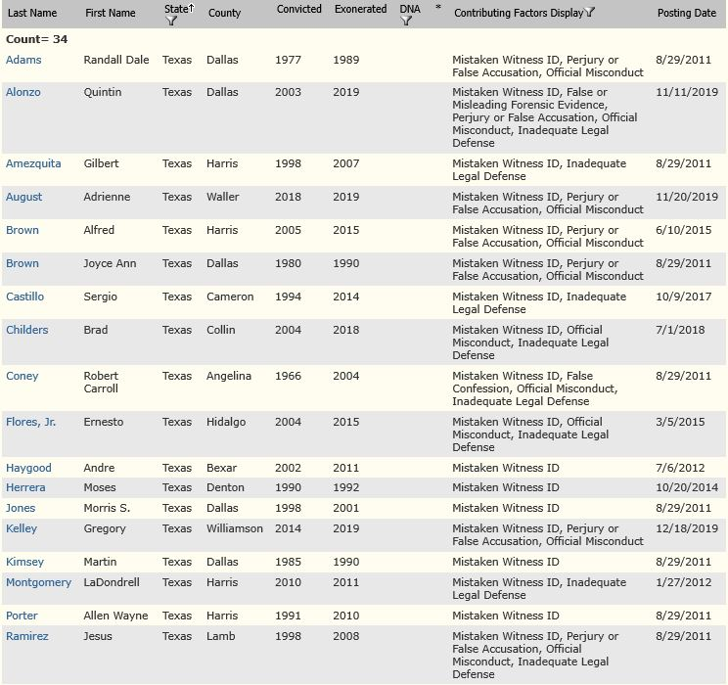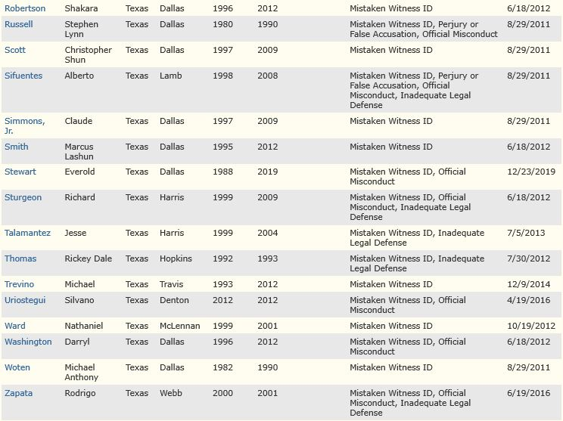

APPENDIX B: SAMPLE PHOTOGRAPHIC LINEUP FORM
Montgomery County Precinct 3 Constable Office
Photographic Lineup
Case Number: ____________________________
Photo Lineup Administered by: ____________________________
Photo Array Compiled by: ____________________________
Order of Photographs shown: ____________________________
Read the following to the witness:
- You will be shown a number of photographs.
- I have been asked to show these photographs to you, but I do not know the identity of the perpetrator.
- These photographs are numbered, and I will show them one at a time, in a random order. Please take as much time as you need before moving to the next photograph.
- All of the photographs will be shown even if you make an identification.
- The person who committed the crime may or may not be in this lineup and you should not feel compelled to choose anyone.
- Regardless of whether you make identification, we will continue to investigate this incident.
- If you recognize anyone, please tell me which photograph you recognize and how or why you recognize the individual.
- You should not discuss the identification procedure or its results with other eyewitnesses involved in the case and should not speak with the media regarding any identification you may make.
- If you make an identification, I am required to ask you to state in your own words, how certain you are if you make an identification
Statement of viewer
I, ______________________________________________understand the above information.
On the ____ day of ____________, 20____, at __ o’clock __m, I viewed a photo lineup. This lineup contained photographs of ________ persons.
- I did identify the person with the number ________.
Identification comments/Level of certainty: ___________________________________
________________________________________________________________________
Viewer’s Signature: ________________________________________
- I was unable to positively identify any of the persons in the lineup.
Viewer’s Signature: _________________________________________
Other persons in attendance during lineup-including any translator if used:
_________________________________________________________________________

1 | CASE #:  VIEWER SIGNATURE:  VIEWER COMMENTS:

2 | CASE #:  VIEWER SIGNATURE:  VIEWER COMMENTS:

3 | CASE #:  VIEWER SIGNATURE:  VIEWER COMMENTS:

4 | CASE #:  VIEWER SIGNATURE:  VIEWER COMMENTS:

5 | CASE #:  VIEWER SIGNATURE:  VIEWER COMMENTS:

6 | CASE #:  VIEWER SIGNATURE:  VIEWER COMMENTS:

APPENDIX C: BLIND PROCEDURE
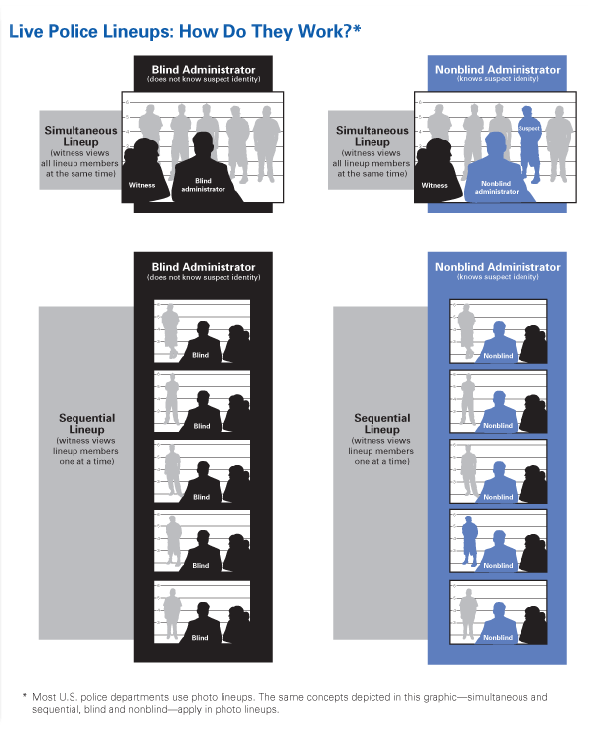
Source: https://nij.ojp.gov/media/image/19686
Note: Simultaneous Lineup is not typically utilized. Sequential Lineup shown here can either be through the printed photo array or the sequential live lineup.

